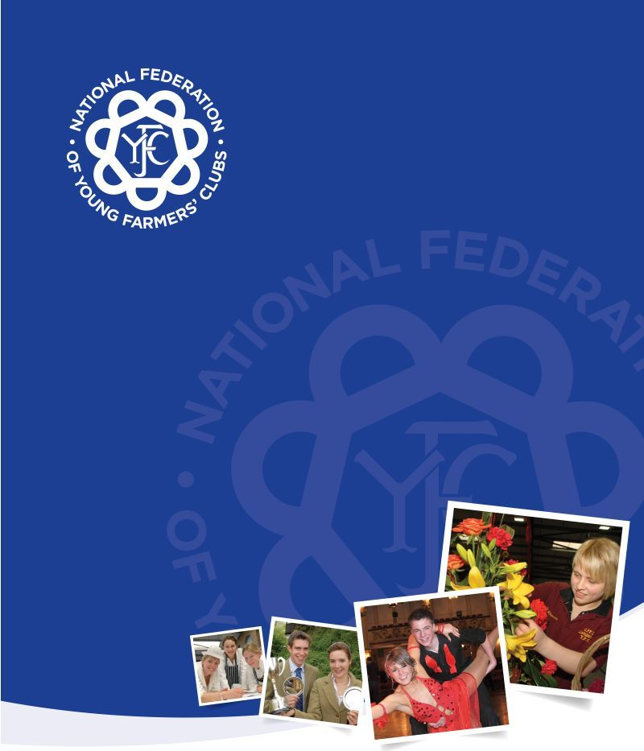

Equality and Diversity Policy and Guidance
Adopted June 2013 -Paper Number P & G 106 (formerly P & G 002)

YFC Equality and Diversity Policy

Statement of intent

We encourage and welcome all young people aged 10 to 26 to join YFC whatever their background including disability, sex (gender), gender reassignment, pregnancy and maternity, race, religion or belief, sexual orientation and age. YFC is committed to valuing diversity by providing equality of opportunity and anti-discriminatory practice for all members, potential members, associates, guests and volunteers.
Our code of equality
We provide a safe environment in which all our members can flourish and in which all contributions are valued. We make inclusion an integral part of our programme of activities and value the contribution of all members to our understanding of equality and diversity.

We believe that everyone has the right to be fairly treated and work in partnership with others to improve our knowledge and understanding of issues of anti-discriminatory practice, promoting equality and valuing diversity so as to comply with relevant legislation. Any complaints we receive about the way we operate are dealt with in a professional and prompt manner.
We do not treat our members unfairly on the basis of disability, sex (gender), gender reassignment, pregnancy and maternity, race, religion or belief, sexual orientation and age.
Accessibility
Information about us can be found through our local adverts, information leaflets and website or by contacting our county YFC office.
We use a local meeting venue which is accessible young people and make reasonable adjustments for disabled people aged 10-26 years old to join and access the benefits of YFC. Due to the typical location of young farmers clubs, in rural villages we are often limited in our venue choices, where this is the case we will look at possible options both with the existing venue and alternatives to accommodate members joining the club. The YFC officers take into consideration the needs of members when planning activities and making decisions and work with parents and other agencies to support individuals in participating in these YFC activities.
When a new member joins they are required to complete a membership form that is discussed between the club officers in order to assess the member’s requirements to participate and how they can begin to address these within their club. When creating this support plan we involve the parents and when required external agencies in order to ensure that the member is fully supported and that the club feel confident that they can accommodate the member.

Health and Safety
The health and safety of all our members is extremely important to us and we recognise within our risk assessments the different needs that members may have.

Club Programme
YFC’s programmes and activities encourage members to develop their own self-awareness as well as an awareness of others. We do this by:
- making members feel valued and good about themselves
- allowing members to input into programme planning
- ensuring that members have equality of access to programmes and activities
- recognising the range of skills and abilities of members and incorporating this into the programme of activities
- avoiding using stereotypes or derogatory images
- creating an environment of mutual respect and tolerance
- helping members to understand that discriminatory behaviour and remarks are hurtful and unacceptable
- including cultural awareness

Employment and Training
Employed staff and volunteers such as club officers and club leaders work to the NFYFC’s Policy of Equality of Employment. Our club officers are offered training to ensure that they are aware of their legal duties and share ideas for inclusion and diversity.

Partnership with parents and guardians
YFC aims to create a warm and friendly environment where parents/guardians feel able to communicate and voice their opinions freely. When the member joins YFC we work with parents to ensure that the members’ needs including medical, cultural and dietary needs are met effectively. Then throughout the year we communicate with parents both verbally and in written form, through newsletters, notices and leaflets. Any changes in policy are communicated with parents/guardians via the YFC.

Valuing diversity
As a member-led organisation, we welcome the diversity of our membership as it inspires an enriched programme of activities from club to national level which ultimately leads to more exciting opportunities for the personal development of our members.

Adopted: 30th June 2013
Review date: June 2016

Equality and Diversity Policy Guidance for Clubs

Statement of intent

YFC welcomes all young people aged 10-26 whatever their background including disability, sex (gender), gender reassignment, pregnancy and maternity, race, religion or belief, sexual orientation and age. YFC is committed to valuing diversity by providing equality of opportunity and anti-discriminatory practice for all members, potential members, associates, guests and volunteers.

Aim

YFC aims to:
- welcome and encourage new members to join
- provide a safe environment in which all our members can flourish and in which all contributions are valued
- include and value the contribution of all members to our understanding of equality and diversity
- improve our knowledge and understanding of issues of anti-discriminatory practice, promoting equality and valuing diversity
- make inclusion an integral part of our programme activities
- provide positive non-stereotyping information about gender roles, sexual orientation, diverse ethnic and cultural groups and people with disabilities
- make sure that YFC is accessible to all young people aged 10-26 wishing to join
- make sure that everyone has the right to be fairly treated
- work in partnership with others to promote equality and diversity
- comply with relevant legislation
- Respond promptly to any complaints about the way we operate

The legal framework – Equalities Act 2010

This policy is based on the Equalities Act 2010 which came into effect on the 1st October 2010.

The Act brings together the legal requirements on equality that the private, public and voluntary sectors need to follow - simplifying it, removing inconsistencies and making it easier for people to understand and comply with.

It replaces all the existing equality law including:

The Equal Pay Act 1970

The Sex Discrimination Act 1975

The Race Relations Act 1976

The Disability Discrimination act 1995

It affects equality law at work, in delivering services and running clubs.

The Act protects people from discrimination on the basis of protected characteristics.

These are:

Disability

Sex (gender)

Gender reassignment

Pregnancy and maternity

Race

Religion or belief

Sexual orientation

Age (effective from 1 October 2012)

It strengthens the law to help tackle discrimination and inequality.

Young Farmers’ Clubs as defined under the Act

As a voluntary organisation, we must operate within all the equalities legislation as we would any other legislation. There are no opt-outs which means it is important that we understand what the law says about equality and discrimination.

The Equality Act 2010 is implemented differently depending on the type of organisation or business it applies to. For example the Act applies differently for businesses and private sector companies. Under the Act a Young Farmers’ Club could be classed as a voluntary service provider, as an association or even both. If your club has a service level agreement with a public sector organisation to provide services on behalf of the public sector then there are extra requirements to be made. In this case work with your service provider, County Federation or NFYFC. i.e if your federation receives grant funding from the local council. You may be required to work under the council’s equality and Diversity policy in order to receive funding.

Young Farmers’ Clubs as a service provider
As a voluntary youth organisation that provides services to rural young people, the Equality Act outlines how you should treat people in the delivery of these services and recommends that treating people fairly should underpin every aspect of this. This means not discriminating against people on the basis of their protected characteristics (listed on page 1) by refusing to provide a service to them, or by providing a lower standard of service or offering a service on different terms than you would to other people. Under the Act, your members would be classed as service users.
As a service provider (YFC) must formally adopt an equality policy and draw this to the attention of all officers and members and consider whether any further training is required.

Young Farmers’ Clubs as an Association

Under the Act, an association is a voluntary or community organisation that:

Has a group of 25 or more members and

has rules (not necessarily formal or written) regulating who can be a member and there is some process of selection to become a member, such as nominating or voting in associate members, or new members to welcome them to the club.

NFYFC would encourage YFC’s to have ‘Welcome of new members’ on the club’s agenda rather than voting in new members by existing members. This is to ensure that the voting system cannot be abused to prevent YFC members choosing who can and cannot join the club based on whether or not they like them. Please refer to The Source/Making it happen/welcome new member’s factsheet for further information. If, however, your clubs does use a voting system then you must ensure that your club does not discriminate, harass or victimise in:
- the arrangements for selecting or rejecting new members and the terms for joining
- the ways in which your club gives or denies membership benefits or services, removes or varies the terms of membership to members or associates
- the arrangements made for deciding who can be invited as a guest.

As an association the Equality Act applies to YFC members, potential members, club officers, volunteers, associates, guests, potential guests and parents.

For those clubs where there are less than 25 members the Equality Act does not apply, however, NFYFC would strongly recommend that you follow the good practice within this guideline to avoid any issues of discrimination or unfair treatment.

YFC code of equality

The Act protects service users or existing and potential members, club officers, volunteers, associates and guests from discrimination on the basis of protected characteristics (disability, sex (gender), gender reassignment, pregnancy and maternity, race, religion or belief, sexual orientation and age). Based on this, YFC officers, leaders, members and volunteers will not therefore:

Harass or victimise service users, members, potential members, associate members or guests
- Discriminate against anyone associated with a person with protected characteristics. E.g discriminating against a member because his brother is disabled, or gay etc
- indirectly discriminate by applying a policy or procedure that puts or could put member with a protected characteristic at a disadvantage
- Wrongly assume someone has a protected characteristic. For example if a club officer thinks a guest looks too young to be drinking alcohol and tells them to leave, then this would be discrimination. It is important to ensure you have the facts before taking action in a situation
- treat anyone badly because they have complained about discrimination or helped someone else complain or done anything to uphold their own or someone else’s equality law rights

Refuse membership to a person. This does not include those that have been subject to disciplinary or safeguarding investigations and have had their membership revoked for the safety of themselves and others.

YFC will endeavour to:
- make reasonable adjustments for disabled people aged 10-26 years old to join and access the benefits of YFC as far as reasonably possible and to the same standard offered to non-disabled members
- Consider the impact of club decisions and whether this could have a negative impact on people with a particular protected characteristic than on people who do not.

Accessibility
YFC aims to ensure that our clubs are accessible to all young people aged 10-26 wishing to join. We seek to do this by:
- advertising YFC widely within the local community
- having a webpage and links from the County Federation and NFYFC
- using social media platforms for communication about YFC and their events
- reflecting the diversity of members in our publicity and promotional materials, providing information in clear, concise language, whether in spoken or written form
- ensuring that all parents are made aware of our equality and diversity policy
- working closely with the parent/carer and other agencies when necessary for the development of an individual member
- Ensuring the Equality and Diversity Policy runs in conjunction with other NFYFC policies such as Safeguarding, Standards of Behaviour, Anti-bullying Policy, Health and Safety Policy and Employment Policy.

Information and advertising

YFC will ensure that all information and advertising is not discriminatory for example when deciding on wording and images for club shirts or designing posters for events. When providing written information to members we will consider their needs and whether any alternative measures need to be taken, for example producing the information in large print or in electronic form such as a membership form
We will ensure that the content on our website is not discriminatory and that reasonable adjustments have been made to make sure that the website is accessible to disabled people.
Example of discrimination:
- If someone advertising a service (for example, by putting a notice in a shop window) makes it clear in the advert that people from a particular ethnic group are not welcome, this would amount to direct discrimination because of race against people who might have considered using the service but are deterred from doing so because of the advertisement. (Equality Rights Commission - http://www.equalityhumanrights.com/advice-and-guidance/service-providers-guidance/your-responsibilities-when-delivering-services/advertisements-and-marketing/)

Disability
YFC works to remove barriers that disabled young people may face in accessing club activities and understands that clubs are able to make additional considerations to ensure disabled young people can participate. We do this by:
- Considering the club’s meeting venues to ensure that they are accessible to disabled young people including the entrance, signage, communication, and toilets. It is up to the club committee to choose a suitable venue in the first instance.
- Considering the needs of potential disabled members with a range of impairments, such as people who have a visual impairment, a hearing impairment, mobility impairment or a learning disability.
- Considering the needs of members with additional behavioural needs such as ADHD or Aspergers Syndrome.

- Working with local or national organisations, agencies including social care or educational establishments, parents and family in seeking help and assistance to ensure that all reasonable adjustments have been made in enabling a disabled young people to join and participate.
- Reviewing the way we do things and if we find they create barriers for disabled members then we will consider how we make changes.

Example
One young person who is a member of a club has an autistic spectrum disorder and sometimes misunderstands instructions which are not given in very direct language. This means they sometimes need to be told what to do a second time and in a different way. Club officers accept that the young person is not being uncooperative when they do not always do what they are asked to do the first time. In behaving like this, the club has made a reasonable adjustment to the standards of behaviour it applies.
If in the instance club officers did decide that the young person’s behaviour was causing more significant difficulties for other members or for the club officers/leaders in charge and that all possible reasonable adjustments had been made, YFC would have to objectively justify the stopping of the young person attending. The club will need to keep notes and records from the outset and seek advice early on from their County Equalities Team, county YFC office and NFYFC.
YFC needs only do what is reasonably possible. What is reasonable depends, among other factors, on the size and nature of your club and the nature of the facilities or activities you provide. Whilst there is no legally recognised formal process or procedure for determining what is ‘reasonably possible’, YFC should research and document all potential avenues including cost. Each situation is different and needs to be looked at individually. If a disabled person can show that there were barriers that should have identified and reasonable adjustments that could have made, they can bring a claim in court, and YFC may be ordered to pay them compensation as well as make the reasonable adjustments.
It is important to ascertain from the outset the needs of new members. When a new member joins they are required to complete a membership and if required an additional needs form that is discussed between the club officers and parents in order to assess the member’s requirements to participate and how they can begin to address these within their club. When creating this support plan it is helpful to involve the parents so that the parents have a good understanding of YFC how is it run and what the clubs rules are explaining what is and what is not acceptable behaviour. When required, do work with external agencies in order to ensure that the member is fully supported and that the club feel confident that they can accommodate the member. If a member with identified additional needs wishes to join or has joined and the required support cannot be accommodated due to the capabilities of the volunteers running the club then it may or could lead to refusal of membership.

Health and Safety
YFC will follow the Health and Safety policy to ensure that risk assessments are carried out for all members, guests and volunteers including those with protected characteristics such as disability, age or pregnant members and will make any necessary changes.

Club Programming
YFC’s programmes and activities encourage members to develop their own self-awareness as well as an awareness of others. We do this by:
- making members feel valued and good about themselves
- allowing members to input into programme planning
- ensuring that members have equality of access to programmes and activities
- recognising the range of skills and abilities of members and incorporating this into the programme of activities
- avoiding using stereotypes or derogatory images
- creating an environment of mutual respect and tolerance
- helping members to understand that discriminatory behaviour and remarks are hurtful and unacceptable
- having varied club programmes which expose members to the cultures of others in order to raise awareness for example the Discovery Programme

Training
YFC club officers and leaders need to be aware of how to behave so that they do not discriminate against people because of a protected characteristic. Even if the person who has been discriminated against does not bring a legal case, YFC’s reputation may suffer. YFC will work with the County Federation, NFYFC and local training providers to ensure that club officers and members are aware of their obligations. Contact your County Equality and Diversity team, county youth association or Jodie Green at NFYFC for assistance.

Employment
Employed staff and volunteers such as club officers and club leaders will follow the NFYFC’s Policy of Equality of Employment.

Using external providers
YFC will inform any external person or body providing services to us of our Equality and Diversity policy and ask that they comply with it. (we are legally responsible for their acts of discrimination, harassment and victimisation even if we do not have a formal contract with them.) For example this will include judges, speakers, trainers and producers.
Partnership with parents

- We work with parents when the member joins YFC to ensure that their needs are met effectively
- We work in partnership with parents to ensure that information is communicated clearly both verbally and in written form, through newsletters, notices and leaflets
- Any changes in policy are communicated with parents
- We encourage parents to become involved in fundraising and social events throughout the year
- YFC aims to create a warm and friendly environment where parents/carers feel able to communicate and voice their opinions freely
- We work in partnership with parents to ensure that the medical, cultural and dietary needs of children are met.
- Our work is intergenerational as we work with parents and advisors to support members.

Valuing diversity
As a member-led organisation, we welcome the diversity of our membership as it inspires an enriched programme of activities from club to national level which ultimately leads to more exciting opportunities for the personal development of our members.

Further information
Equality Advisory and Support Service http://www.equalityadvisoryservice.com/
Charity Commission http://www.charity-commission.gov.uk/
Children’s Alliance for England (CRAE) http://equalitymattersforchildren.crae.org.uk/
Equality and Human Rights Commission http://www.equalityhumanrights.com/
Government Equalities Office- Equality and Diversity Forum http://www.edf.org.uk

Useful Publications
Equality Act 2010: What do i need to know? A quick start guide for voluntary and community sector associations - Government Equalities Office- Equality and Diversity Forum (2010)
Equality and Human Rights Commission Equality Act starter kit (online modules)
What equality law means for your association, club or society – Equality Human Rights Commission (2011)

We would like to thank the Warwickshire Equality and Diversity Team for reading and reviewing our policy to ensure it is fit for purpose.
Adopted: 30th June 2013 Review date: June 2016

Glossary

Discrimination
Direct discrimination occurs when a person is treated less favourably than another person has been, or would be, treated because of a protected characteristic.

Duty to make reasonable adjustments
Where a disabled person is at a substantial disadvantage in comparison with people who are not disabled, there is a duty to take reasonable steps to remove that disadvantage by (i) changing provisions, criteria or practices, (ii) altering, removing or providing a reasonable alternative means of avoiding physical features and (iii) providing auxiliary aids.
Harassment
Unwanted behaviour that has the purpose or effect of violating a person’s dignity or creates a degrading, humiliating, hostile, intimidating or offensive environment
There are three types of harassment:
- Harassment – disability, gender reassignment, race or sex this now applies to service users not just employers
- Sexual harassment – this includes unwanted behaviour that is sexual in nature verbal or non-verbal such as gestures, comments and sexual touching.
- Harassment linked to rejection or submission to unwanted behaviour – this means treating a service user unfairly because the service user has rejected or submitted to unwanted sexual behaviour. The unwanted behaviour can come from the service provider or another person.

Harassment linked to religion or sexual orientation is not covered specifically but could amount to unlawful direct discrimination if the service user suffers disadvantage when compared to the treatment of other service users.
Indirect discrimination
This occurs where a person applies a provision, criterion or practice in the same way to all people within the relevant group but which is such that it puts – or would put – children and young people sharing a particular protected characteristic at a particular disadvantage when compared with persons who do not share it. (Children England)
Victimisation
The subjection of a person to a detriment because he or she has brought or is going to bring, or is believed to have brought or be going to bring, in good faith, proceedings under the Equality Act 2010. It can also be where a person has given evidence or information in connection with proceedings under the Act; done anything for the purposes of or in connection with the Act; or made any allegations that another person had contravened the Act. (EHRC)

